Emma Smith-Hunter
1206684
Keedo Campus App
Part 1: Client Report

Part 1 Word Count: 4107
Part 3 Word Count: 3108

BSM730: Digital Marketing Project

This report will create an understanding of Keedo’s place in this market, their potential partnerships/influencers and their future aspirations for when their mobile application is launched.
This strategy is using the RACE framework to help create a modern marketing campaign applying the Smart Insights RACE planning approach:
- Reach: Attracting visitors through content and performance marketing (paid media)
- Act (encourage interaction and leads on campaign landing pages or microsites): Engaging website visitors with the brand / proposition using an effective site
- Act (encourage interaction and sharing on social media using content marketing): Developing content marketing assets / storytelling to make the campaign engaging and shareable on social
- Convert (online): Encourage online conversion (e.g. sale, lead) on the target landing page
- Engage: Increasing reach using email, social media and personalised promotions on site to existing customers, email contacts and social media followers to spread the word

Table of Contents
Background 4
Objective setting. Where do we want to be? 5
Key Issues 5
SWOT Analysis 6
Goal Overview 7
Objectives 7
Summary 8
Situation Analysis: 9
Where are Keedo Now? 9
Consumer Profile 10
Personas 10
Competitor Analysis 13
Influencers and Partnerships 15
Social Media Marketing 16
Search Engine Optimisation 18
Google Analytics Analysis 19
Project Overview 22

Background

Situated in Aberdeen, Keedo was founded in 2016 by Managing Founder Ross Mclean and silent partners Tiffany Young and Jess Dunham with Jess leaving in 2017. In early 2018 Keedo launched the original alpha version of the app which focused on giving students instant access to services such as library availability and timetabling with the notion of doing a full beta launch in September 2018. This focus of the Keedo app would see the company sell these services to institutions.
Upon discussing this project offering with Keedo they changed their focus. While the app would still have a student target audience focus, new features would be added to improve potential usability. By changing their focus Keedo hope to eliminate the need to have a B2B focus.
In August of 2018, Keedo changed their full beta launch from September 2018 to September of 2019.

Objective setting. Where do we want to be?

Keedo aspire to the mobile app of choice for all students studying at college or university level. They understand that their growth should be rolled out with the premise of providing future audiences with the best experiences.

Key Issues

Reach audience
- Having a functional website which can start informing target audiences decision making process.
- Current landing page does not inform users of what Keedo plan to offer or direct traffic to other Keedo channels.

Increase interaction with audience (Act)
- Encouraging users to share their thoughts in a positive manner.
- No real social media usage by Keedo
- Currently not directing traffic to current landing page.

Conversion to customers (Convert)
- Creating content that encourages audiences that Keedo is the app they need.

Engage with customers (long-term)
- Keeping audiences up to date and engaged with the Keedo brand.
- Responding to engagement given by consumers.

Other
- Keeping track of analytical data to ensure marketing tactics are providing value to the business and are matching goals and objectives.

SWOT Analysis

The SWOT analysis below is focused on the abilities of Keedo’s marketing efforts other than the general analysis of the business as a whole. By analysing Keedo’s efforts in this format a plan as to future marketing efforts can be considered.
 | Strengths (Internal) | Weaknesses(Internal)
 | - Clear defined target audiences – a clear defined audience ensures that Keedo has their niche area.  - Student mind-set – Keedo was founded by an ex student who therefore knows their audience and can relate to them. | - Limited finances- Limited funds means that there is no real budget for marketing.  - No workforce – resulting in chances of strategies not being adhered to as a way to save time. Furthermore, there is no one to work on marketing efforts.
Opportunities (External) | SO Strategy | WO Strategy
- Influencers – can drive traffic to Keedo and encourage downloads  - Partnerships – Similar to influencers, partners give opportunity to influence audience  - Little direct competition- Less crowded marketplace gives Keedo an edge. | - Storytelling Content which matches target audiences and their needs. Showing audiences that Keedo knows their pain points provides potential influence.  - Encouraging appropriate influencers and partners to get on board with Keedo. | - Influencer Demo Nights to get popular generic influencers to see product and hope they talk about it  - Partner Event Sharing on social media in hopes it drives audiences to Keedo channels.
Threats (External) | ST Strategy | WT Strategy
- No online presence – As a start-up Keedo have no influence over its target audience as it has no awareness online.  - Vast indirect competition- competition in each feature of Keedo’s app have a greater influence on target audience | - Generic Marketing tailored to audience. | - No strategy  - Hope discovery of app happens naturally.

Goal Overview

Keedo has chosen the following goals as success factors for the first stage of the app being live.
- 100 weekly downloads
- Usage rate of 1 per week
- 10% Uninstall rate

Objectives

To achieve these goals, SMART objectives have been set in alignment with the RACE framework.

Reach (Acquisition)
Objective: Increase views by 20% each month across all channels
By basing this objective across all channels Keedo can determine if marketing efforts are working as indicted more directly. By creating strong engaging which drives users to multiple platforms it highlights relationships are being formed and users are engaged. Reaching these audiences will also spread word of mouth. Do to this content and offerings need to highlight value Keedo can bring and be entertaining.
KPI: increased reach, page views, visitors, new visitors

Act (Acquisition)
Objective: Achieve a referral rate of 25% by the end of launch period
Keedo’s main marketing platform will be their social media platforms. Over the past 3 months’ social media has resulted in 25.86% of users and 24% of sessions. However little information is given as to indicate what is bringing users to the site. Instead Keedo should aim to drive traffic to their site using referrals. By focusing on referrals Keedo can analyse the referral source, medium and content. The 25% rate was chosen to match that of the current social statistic which is the current benchmark.
KPI: Increased referral rates, increased rate of new visitors,

Convert (Acquisition / Conversion)
Objective: Acquire 1200 qualitative downloads by the end of the launch period (3 months) by creating authentic content which guides potential users down the conversion funnel.
By creating content for every stage of the conversion funnel they are allowing users to see the value that the app will bring to them. It will allow them to align Keedo’s goals with their own. This content has to be of high value that will ultimately encourage users to feel engaged with Keedo. By creating authentic content users will feel like they are part of something and will appeal to them in a relatable way.
KPI: Increased Usage Rate, Increased Conversion Rate (100 per week)

Engage (Retention)
Objective: Provide Valuable and Education content over launch period (3 months) to decrease uninstall rates.
By providing valuable and education content that users can engage and relate to should establish a sense of trust. This trust should then have an impact on the usage of the app and the rate of which it becomes a trusted app that users will use often.
KPI: Decreased uninstall rates maximum 10%. Increased Usage Rate

Summary

At present Keedo have a clear line of sight for where they want to be. Their goals match their vision and as such the proposed campaign strategy will also reflect their ambition. To help understand how Keedo can achieve these goals, the next section explores and gives an understanding as to their current situation. This will help align these goals to exact areas in the campaign strategy.

Situation Analysis:

Where are Keedo Now?

At present Keedo has spent two years in the app’s development stage. The main reason for this is due to a change of focus after the launch of their alpha project, in which Keedo solely worked as a student information systems platform. This platform allowed students to look at their timetables and library services. During these years Keedo’s founder Ross Mclean was completing his masters at university.
The new focus of the Keedo app will be to provide other services such as crowdfunding, event finding and book selling and exchanging. They are also in talks which other service providers such as recruitment providers to allow students to access work experience alongside their studies.
To understand the impact Keedo will have on their overall target audience, the client has decided that the first stage of app deployment should first be based around Aberdeen institutions Robert Gordon University and the University of Aberdeen. Once these initial target areas have showed their usage of the app Keedo plan to start rolling out the app to other institutions across the United Kingdom.

Consumer Profile

Keedo’s target audience is students with smart phones who will be able to access the app.
To help aid with the understanding of the research behaviour of the target audience an initial questionnaire found the following results.
- 100% of students would use search engines as part of their research process. Following on 84% of respondents would use google while 23.1% would use app stores such as play store and app store.
- 69.2% of students would use websites as part of their research process with students saying that they would mostly use university websites and an applications own website.
- 61.5% of respondents claimed they would not use social media as part of their research process. Of the 38.5% who said they would use social media, Facebook and LinkedIn were the most popular channels of choice for research.
- When asked if they would sign up for email newsletters to receive information about an app, 76.9% said they wouldn’t sign up for the service. For those that would sign up 55.6% would prefer personalised emails based of their name and university of study.

Personas

The buyer’s personas are focused on Aberdeen University and Robert Gordon University students as they are initial demographic for the app’s launch. These personas cover a range of characteristics such as age, subject and nationality and aligns their goals and challenges with the app. While there may be other goals that these personas face while at university Keedo should only focus on what they can help solve and how they can do this. These personas were created using research complied both as part of this strategy and previous target audience surveys.

Name | Characteristics | Goals | Challenges | Keedo’s Solution | What we can deliver through digital channels
George Middleton | - 21 Years Old  - Male  - Newcastle Native  - 2nd Year BSc Forensic and Analytical Science at Robert Gordon University  - Forensics Society Member | - Find events on campus relating to his studies | - Finding information about on campus events | - Events Feature | - Awareness of event feature  - Information blogs  - Vlogs or videos with tips and tricks to finding events
Rebecca Jones | - 18 years old  - Female  - Aberdeen native  - 1st year BA Business Management and Politics at Aberdeen University | - Find off campus events where she can meet new people  - Wants to buy books relating to her studies | - Social media is cluttered with events and other posts that she is unable to find events which match her needs.  - Textbooks are expensive if living of a Student income | - Events Feature  - Book exchanging Feature | - Awareness of event and bookselling feature  - Information blogs  - Vlogs or videos with tips and tricks to finding events and selling books
Alexander Stoven | - 27 years old  - Male  - 4th Year BSc Computing Science at Aberdeen University  - AU Rugby Club President | - Sell textbooks  - Raise money for charities with Rugby team. | - Selling online can be daunting  - Cash payments limit who and how people donate. | - Book exchanging Feature  - Crowdfunding Feature | - Awareness of book exchanging and crowdfunding feature  - Information blogs  - Guides on how to set up crowdfunding and book selling
Margaux Raymond | - 25 years old  - Female  - Canadian  - MA Fashion and Textiles at Robert Gordon University | - Donate to fundraisers on campus | - Never carries cash | - Crowdfunding Feature | - Awareness of crowdfunding feature  - Information blogs  - Vlogs or videos with tips and tricks to finding events
Anna Henderson | - 20 years old  - Female  - Glasgow  - 2nd year BA Applied Social Science  - Gaming Society President | - Promote events ran by the society | - Only reach a limited people on social media. These people are already aware of the society. | - Events Feature | - Awareness of events feature  - Guides on creating events  - Information blogs

Competitor Analysis

Keedo plans to launch an app which overlap several individual services. The below competitor analysis covers main competitors across three of their key features. It is important to note that these competitors were chosen from a larger list and as such do not fully reflect the business area they are in.
Criteria | Competitor | Competitor | Competitor
Business Name | Myday by Collabco | Goodbox | Webuybooks
Business Area | Student Portal | Crowdfunding Solutions | Bookselling
URL | https://www.collabco.co.uk/ | https://www.goodbox.com/ | https://www.webuybooks.co.uk/
Reach KPIs  - Social audience / reach  - Search engine visibility  - Inbound links (Backlink profile) | Audience total across social media channels: 926  Digital channels are B2B orientated with a corporate approach.  Ranking 1st page/5th position under search term ‘student portal app’  Homepage link total 3.3k with a domain authority of 24. | Audience total across social media channels: 2,456  Digital channels are B2B orientated with a friendly and engaging approach.  Unable to find under any search term other than the business name.  Homepage link total 32 with a domain authority of 13. | Audience total across social media channels 28,316  Digital channels are B2C orientated with a engaging approach.  Ranking 1st page/1st position under search term ‘selling textbooks’  Homepage link total 11 with domain authority of 39.
Act KPIs  - Landing Pages  - Website effectiveness | Landing page provides a clear call to action both at the top and bottom of the page.  Landing page provides an overview of the service they provide.  Page load time of 3.08 seconds | Website features the one-page layout.  Call to action is not clear with the page having little information about the service they provide. However, the page features videos about the product.  Page load time of 1.07 seconds | Landing page provides clear calls to action throughout one-page layout.  Landing page provides clear information about the service.  Page load time of 12.2 seconds
Engage KPIs  - Recommendation, satisfaction scores, community and email benchmarks  - Social shares / Likes / comments | Little to no social media engagement with audiences across Facebook and Twitter channels.  815 Twitter followers  87 Facebook followers under Collabco page.  26 Facebook followers under MyDay page.  Website features a few testimonials, one social media review. 5 star rating on Facebook | Few social media engagements with audiences across Facebook and Twitter.  Channels active since 2017.  2273 Twitter followers  183 Facebook followers  No testimonials on website, no social media reviews. 5 star rating on Facebook. | Little to no social media engagement unless the share content from popular themes e.g. Harry Potter (Facebook only)  9,983 Twitter followers  18,333 Facebook followers  Website features testimonials, 5 social media reviews. No star rating on Facebook as they use third party review platform.

Competitor analysis shows that while these companies have a varying social media following they receive little social media engagement from their audiences. Each competitor uses a different approach each with different outcomes.
Analysis of how Keedo is performing against their competitors (see Chapter Social Media Marketing) conveys a story that they have an engaged audience, thus potentially allowing for potential influencers and partners when the app launches. However, this follower group is primarily people who know the client and are engaged with his work. As Keedo progresses engagements will need to come from a wider group within the target audience.

Influencers and Partnerships

Partnerships
RGU Union  Aberdeen University Student Association | www.rguunion.co.uk  www.ausa.org.uk
Blogs:
RGU student blog | rgustudentblog.com
Influencers:
AU Societies and sports clubs

RGU Societies and sports clubs

The above list of partners and influencers were chosen as they have a wide student reach. Both university unions are student experience focused so play a vital role in raising awareness of the Keedo app. Similarly, societies and sports clubs hold a connection with their members and hold a value of influence, plus these are the people who will share event information on the app. The app also has the potential to help these groups grow their member base due to the event feature.
The RGU student blog was chosen as their posts are about student life in not only RGU but the city of Aberdeen as a whole. A positive review or post regarding the app will give it some merit and allow students to hear real opinions about Keedo which will help their decision making process.

Social Media Marketing

User Action | Evaluation of current social media: | Recommended improvements:
Potential audience (fans / followers) | LinkedIn: 0 followers  Twitter: 3 followers  Facebook: 20 Followers with highest organic post reach being 1.4k people | Analyse where target audience will be and post content on these channels to match strategy.
Engaging content | Keedo have only published 5 posts across their social media channels with all these posts being on Facebook. At present they have mainly used photo based posts thus giving the impression that photos are the most engaging content type. | Try different types of post content types such as video, links, generic etc. and analyse what is working and to make channels more engaging for audiences.
Engagement (Sharing and Liking) | LinkedIn/Twitter:  As Keedo have not posted content to other channels there is no engagement to be analysed.  Facebook:  Shares:  13 on posts, 15 total shares if you include shares made on shared posts.  Likes:  23 on posts, 105 total likes if includes liked made on post people shared.  Comments:  8 on posts, 17 total including comments from shared posts. | Encourage those who engage to follow the page and continue to engage. Use different content types to analyse if they bring new engagements.
Referral traffic to website | Over the past 12 months Facebook has provided the most social media referrals to Keedo’s website. | Use campaign tracking to accurately monitor movements from referrals.  Post content on other channels to analyse and compare referral rates for target audiences.
Use of video | N/A | Try using video content and analyse results.
Use of images | Images are Keedo’s main post type and therefore provide the most engagement.  The use of images so far have been showing the Keedo team during field marketing exercises or simply showcasing the company’s logo.
Integration with website | No interaction with website. There are no links to website on posts nor is there the ability to find their social channels via their website. | Redesign website to show social media channels.  Post content that links to website to allow audiences to start their decision making journey.

Despite having a low online presence Keedo is starting to create a social media presence. They have continued to reach new people and their posts successfully provide engagements. To amplify this and gain a new following relating to their target audiences Keedo should encourage people to follow their page and provide more engaging content. This content should take the form of a variety of content types to analyse what works for them.
In the future, while the following campaign strategy will place social integration into motion, Keedo should further integrate their social channels with their website and ensure their target audiences can find them with ease. This should include posting content to other popular channels their audience may use and that match Keedo’s needs.

Search Engine Optimisation(SEO)

SEO criteria | Evaluation of current site: | Recommended improvements:
Landing pages | Only one landing page with little information | Create a more welcoming landing page which directs visitors to actions.
On-Page optimisation | No optimisation other than a title and h1 tag. | A more developed website detailing greater product offering.  Fixing page optimisation to include meta data information and image optimisation.
Backlink profile | 66 Inbound Links however majority of these links reference a clothing company of the same name. | Reach out to partners/influencers and ensure they link to the correct landing pages.
Domain Authority | Domain authority of 8 (Moz) | A more developed website detailing greater product offering and page optimisation.  Obtain backlinks from high authority sources.
Internal Linking | N/A | Create a more developed website with optimised pages including meta descriptions which focus on keywords.
Local SEO | N/A | Use google guidelines such as contact information.

SEO analysis highlights that while Keedo ranks highly on search engine results, a lot of improvements are needed for the company to be recognised as a brand and as a level of authority in their chosen market. It also shows that currently Keedo are getting confused with another brand of the same name, this brand is a south African clothing company so are only a competitor in terms of SEO under the brand name. Keedo needs to work on distinguishing itself from that brand and creating backlinks which hold reference in their market.

In addition, this analysis has also indicated that Keedo need to improve on their on-page optimisation to ensure that search engines and social channels are displaying the information they want to convey.

Google Analytics Analysis

Currently Keedo has no real online presence, will they have a website landing page and social media their impact on their niche is rather small. While this limits the level of analytics which can be acquired, Keedo can still be accessed using basic key metrics.

Current site performance
- Audience
In the UK audience data highlights that between April and June, Keedo acquired the majority of total users from Scotland. However, 50% of new users were located in England.

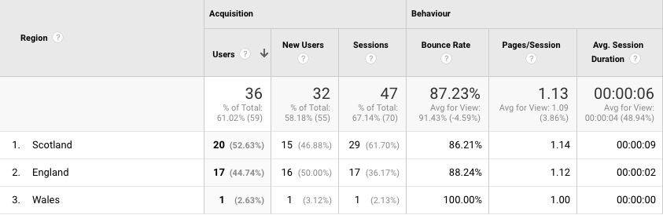

UK users during this time resulted in 61.02% of the overall users, with other users coming to the site from the US (15.25%), Peru (6.78%), the Philippines (5.08%) and Canada (3.39%). Keedo may have reached global markets due to their brand name being the same as a clothing retailer in South Africa.
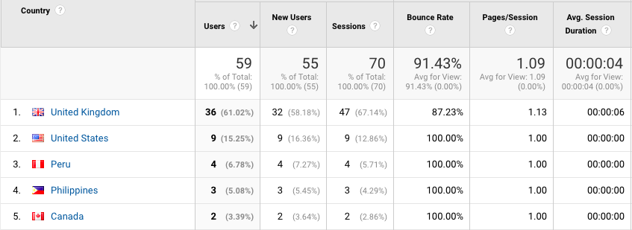

- Acquisition
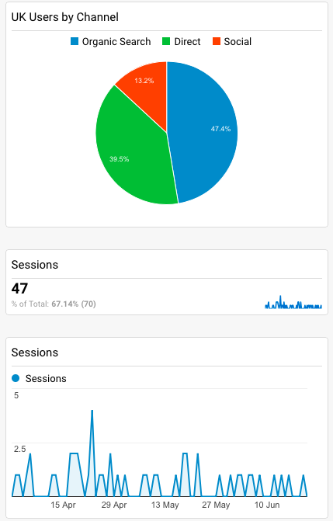
Analytics show that UK users generated 47 (67.14%) sessions from April to June with the majority of these users finding Keedo’s website organically. It is interesting to note that while mobile is deemed to be the industry leader in device types, Keedo’s users primarily used desktop to access the website. However due to a limited website featuring only a landing page with no calls to action any further analysis could not be made.

- Behaviour
Over the period of three months (1st April – June 21st) users in the UK were spending 6 seconds on Keedo’s website, with the reason being lack of information or call to action given. With this result a 100% bounce rate should be expected however Keedo secured a rate of 87.23%. This is due to users from Aberdeen, London and unclear locations having a bounce rates of 94.1%, 80% and 66.6% respectfully.
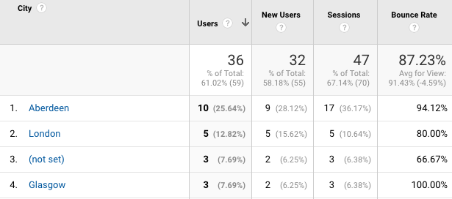

- Conversion
As the app has not launched conversion analytics cannot be given.

Future Goal Setups
- Conversion Rates: Who follows calls to action to their devices app store for download or to become an ambassador of the brand.

Segments to Track in the Future
Important segments for Keedo to track are:
- New vs returning visitors:
By tracking visitor information such as returning vs new users Keedo can analyse who are potentially leads as well as track their journey through their website. This information could also be used to analyse which pages of their website need to be adjusted.
- Non-paid search (SEO traffic)
This will allow Keedo to analyse which keywords and AdWords (if using paid keywords) are working for them. This is important as Keedo with incorrect SEO or a lack of traffic being driven by these words could mean that Keedo’s target audience are not being satisfied and by being unable to see Keedo’s offering will not download the app.
- Referrals
Going forward referral traffic is important for Keedo to consider. This is due to the nature of their target audience. They need to track where their users are coming from and what channels are working for them so they can focus on providing the best they can for their audiences. This may mean using referral rates to eliminate channels that are not working for the company or creating a strategy to re-establish referrals.
The above analysis of Keedo’s analytics show that there is interest in Keedo from their initial target areas. In addition, it highlights that with changes to SEO, website design and social media integration Keedo’s audiences could spend longer on the site and will greater increase acquisition results.

Project Overview

In short Keedo are showing to be building a social audience however there are key areas where improvements are needed. These key areas being Search Engine Optimisation, Social Media Marketing and Website Integration.
The proposed marketing strategy will focus on strengthening the integration of social and organic channels. In addition, the strategy will set a plan for the applications launch using both survey analysis and information gathered from the above. Recommendations will also be made for Keedo’s website design and future social media marketing. Part of this project will also include a redesign of Keedo’s current landing page to align with recommendations set in the Search Engine Optimisation chapter of this report.

Appendix I: Survey Responses

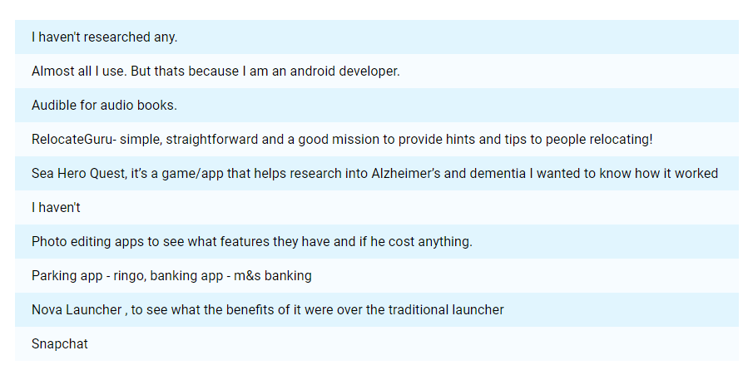
Describe any examples of a mobile application you have researched and why?

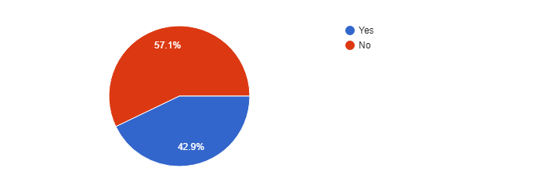
Would you use social media to research mobile applications relevant to your university experience?

If yes, what platforms would you use?
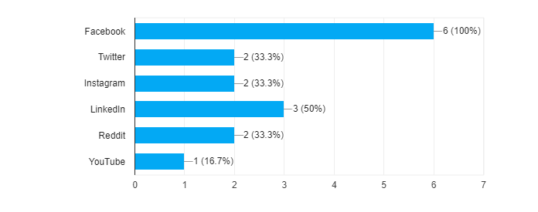
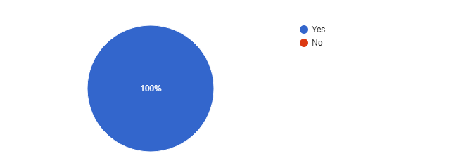
Would you use a search engine to research mobile applications relevant to your university experience?

If yes, which of the following engines would you use?
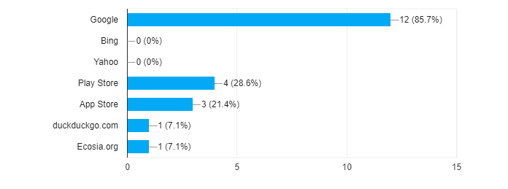

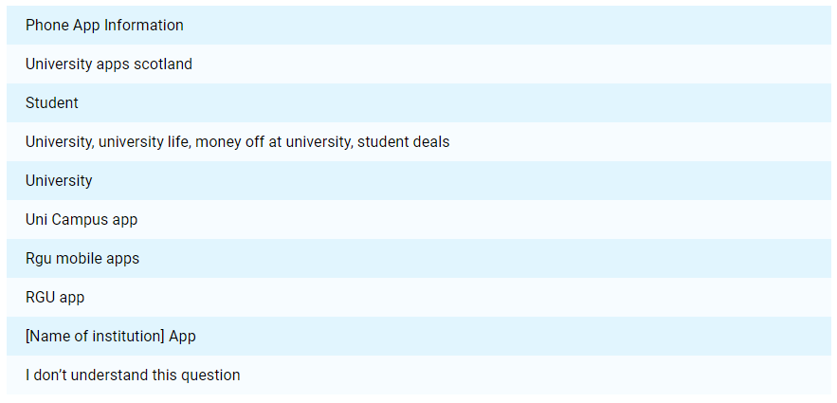
Please type in the search term you would use to research this application.

Would you use a website to research mobile applications relevant to your university experience?
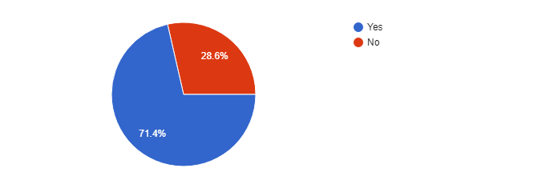
If yes, what website(s) would you use?
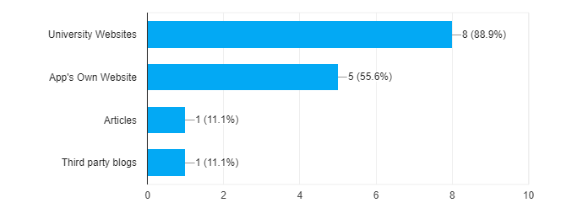
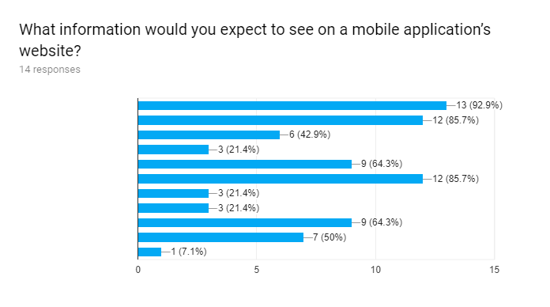
What information would you expect to see on a mobile application’s website?
Straight Link to app store
Features/Services

Release information with ability to register interest
Release information w/o ability to register interest

Screenshots/How To Use Pages

FAQs

Blog

Testimonials

Contact Information

Social Media Links

List of institutions supported

How would you prefer the website to be laid out?
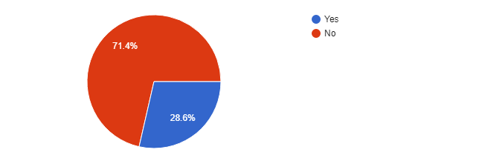
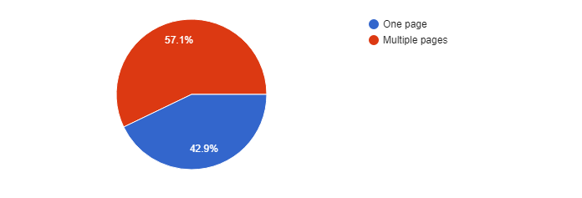
Would you sign up for email newsletters to receive information about a mobile application related to your university experience?

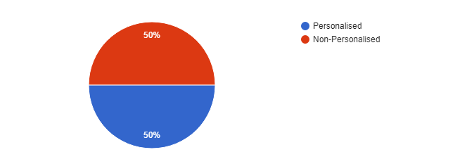
If you were to sign up to email newsletters would you prefer personalised e.g being addressed by name or non-personalised emails?

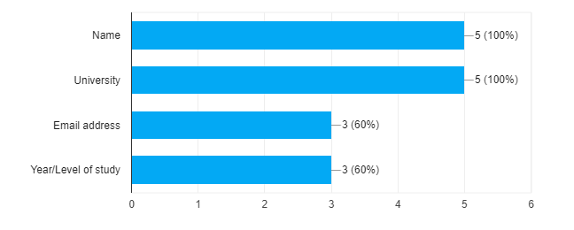
If personalised what information would you give out to allow this?

